**Game to develop reading comprehension skills for children**

Developing concepts of alphabetical face, numbers, pictures, and rhyming for reading develop vocabulary, increase children's reflexes through games. The game administrator can apply the child's listening and predictive mechanisms to help their child practice math, language, and vocabulary skills. According to Kangas (2010), the development of concepts of mathematics and language through games will be the first solid foundation for children to easily absorb and improve their reflexes. Their material is simply made up of paper cards containing squares. Parents and game creators can create themes such as typefaces, pictures, or phrases. However, Olson (2007) emphasizes that creating and changing themes through games will help children feel excited and increase children's ability to develop thinking.

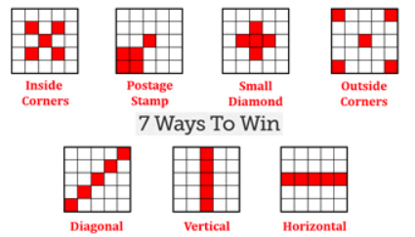Simple game rules include the player (children) to get the corresponding cards the parent has created such as finding a word, solving a calculation, or finding a picture corresponding to the description. The player must find the result boxes to mark them or highlight them with black. If a player finds 5 boxes that form a vertical/horizontal/diagonal line or 4 points in the 4 corners, the player exclaims "Done" and wins.

These are the winning forms of the game (Pinterest, 2020).

Variations of the rules of the game:

* The game administrator can substitute words or pictures on the paper card.
* Don't read out the name/picture in each square but give your child a clue to guess.
* Change the number of squares in the card board, corresponding to the number of words to match the child's level.
* Have your child create a card board with words/phrases that they are impressed within the book instead of preparing them for them.
* If possible, parents should form groups of 2, 3, or more so that children can practice cooperation skills. Finding words faster will increase the game attractiveness.
* When they find a vertical/horizontal/diagonal line, ask them to do something with these squares. For example: form a sentence, create a new story, and write a short paragraph using found words.

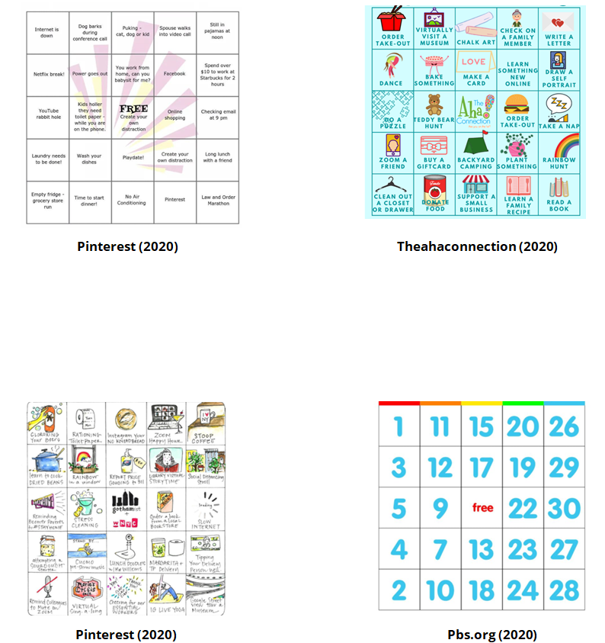Parents can use websites that specialize in the design of free cards to create a variety of eye-catching ideas and images to appeal to younger kids. It includes math calculations, from sesame, or about special places in the world. From there, it will form a habit of thinking and reflecting on children with daily reading habits.

These are visual examples that a game administrator can design with a variety of counting ideas, math, pictures of everyday objects, or literary stories.

When experimenting and playing games, it is difficult for parents or game administrator to come up with suitable ideas for children. Must understand their wants and preferences so that they can orient their gameplay and illustrate accordingly. Besides, when working with a group, the first task is to convince your ideas your teammates, and then you can develop them further. Sometimes there are difficulties with strategy and logic constraints when creating game rules. Furthermore, the skills that employers need are cultural sensibility, pressure tolerance, community, social skills, and the ability to work in groups to come up with problem-solving solutions. The importance of teamwork is being able to exchange ideas, come up with ideas, and do tests together, and fix problems. The lessons I have learned the most are about controlling emotions and confidently developing my ideas for the group.

The list of team members includes Will connel, Connor winspur, Hou Yuen Yap.

**References:**

Kangas, M. (2010) Creative and playful learning: Learning through game co-creation and games in a playful learning environment. *Thinking skills and Creativity*, *5*(1), pp.1-15.

Olson, J. (2007) Developing students' mathematical reasoning through games. *Teaching Children Mathematics*, *13*(9), p.464.

Pinterest (2020) *Pin on Bingo Patterns*. Available from: https://www.pinterest.com/pin/356980707933210123/ [Accessed 8 November 2020].

Pbs.org (2020) *ABCs & 123s Bingo Cards | Kids Coloring Pages | PBS KIDS for Parents*. Available from: https://www.pbs.org/parents/printables/abcs-123s-bingo-cards [Accessed 9 November 2020].

Pinterest (2020) *A Fun Social Distancing Bingo Card to Occupy New Yorkers While the City Is on 'PAUSE' in 2020 | Bingo cards, Bingo, Social*. Available from: https://www.pinterest.com/pin/8514686783634966/ [Accessed 9 November 2020].

Theahaconnection (2020) Available from: https://www.theahaconnection.com/stay-at-home-bingo/ [Accessed 9 November 2020].